Acupuncture Intake Form

Please complete this questionnaire carefully. The information you provide will assist in creating a complete health profile for you. All of your answers are strictly confidential. If you have any questions, please ask.
Name (Last, First): |  |  | Gender: |  |  |  |  |  | DOB:  Age:
Relationship status: |  | Single Common Law Married Separated Divorced Widowed Other
Full Address: |  |  |  |  |  |  | Phone:  Cell:

Email Address:

BC Care Card Number:  Extended Medical Insurer: |  |  |  |  |  |  | Occupation:
Family/Referring Doctor: |  |  |  |  |  |  | Doctor’s Phone:
Emergency Contact:  Relationship to You: |  |  |  |  |  |  | Emergency Contact Phone:
How did you hear about us?

Have you had Acupuncture before?

PERSONAL HEALTH HISTORY
Childhood Illness: |  |  |  | Measles Mumps Rubella Chickenpox Rheumatic Fever Polio
Medical History: |  |  |  |  | Asthma | High / Low Blood  Pressure |  | Kidney Disease
 |  |  |  |  | Arthritis | Pacemaker |  | Liver / Gall Bladder Disease
 |  |  |  |  | Broken Bones | Heart Disease |  | Seizures
 |  |  |  |  | Cancer | Bleeding Disorder |  | Stroke
 |  |  |  |  | Colitis | Hepatitis ____ |  | Substance Abuse
 |  |  |  |  | Diabetes | Herpes / Shingles |  | Thyroid Imbalance
 |  |  |  |  | Gastritis | High Cholesterol |  | Tuberculosis
 |  |  |  |  | Gout | HIV / AIDS |  | Bleeding Disorder

CHIEF COMPLAINTS
Please indicate your chief concerns for your health:

- ____________________________________________________________________________________________________

- ____________________________________________________________________________________________________

- ____________________________________________________________________________________________________

Have you tried any other treatments or therapies for the above concerns and were they effective? Please explain.

Have you been given a specific diagnosis by a health professional for the above? When?

Surgeries / Trauma / Accidents (ex. car accident)
Year | Please Explain:

Medications / Pain Killers / Supplements / Vitamins / Minerals
Name |  |  | Strength |  |  | Frequency Taken

Allergies
Drug / Environment / Food |  |  | Reaction You Have/Had

HEALTH HABITS
Diet | Are you dieting or avoiding certain foods? |  |  |  |  |  |  |  | Yes |  | No
 | If yes, please explain:
 | Do you have any problems with eating or appetite? Please explain.
Caffeine | None | Coffee |  | Tea | Cola / Energy Drinks / Energy Pills
 | # of cups/cans per day?
Daily Activity | What do you do for daily exercise/activity (ex. walk the dog, running, ski, etc.)?
Alcohol | Do you drink alcohol? |  |  |  |  |  |  |  | Yes |  | No
 | If yes, what kind? ___________________________________ How many drinks per week? _________________
Tobacco | Do you use tobacco or have used in the past? |  |  |  |  |  |  |  | Yes |  | No
 | Cigarettes – pks./day _____________________ |  |  | Chew - #/day ______________ | Pipe - #/day ____________ |  | Cigars - #/day _____________
 | # of Years ___________ | Or Year Quit __________
Drugs | Do you currently use recreational or street drugs? |  |  |  |  |  |  |  | Yes |  | No
 | Have you ever given yourself street drugs with a needle? |  |  |  |  |  |  |  | Yes |  | No
 | Have you ever been treated for substance abuse? |  |  |  |  |  |  |  | Yes |  | No
Are you concerned with any of your answers to the above questions? |  |  |  |  |  |  |  |  | Yes |  | No

FAMILY HEALTH HISTORY
 | Age | Significant Health Problems (heart disease, cancer, Mental Illness, arthritis, etc.)

Father

Mother

Grandparent

(M / F)

Grandparent

(M / F)

Sibling

(M / F)

Sibling

(M / F)

MENTAL HEALTH
Is stress a major problem for you? |  | Yes |  | No
Please rate your stress level on a scale of 0 to 10 (0 = no stress; 10 = extreme stress) __________________
Do you feel depressed or anxious? |  | Yes |  | No
Do you suffer panic attacks or heart palpitations when stressed? |  | Yes |  | No
Have you ever attempted suicide or intentionally hurt yourself? When? _________________________________ |  | Yes |  | No
Have you ever seriously thought about hurting yourself or anyone else? |  | Yes |  | No
Have you ever been to a counselor or therapist? |  | Yes |  | No

Neuro-Psychological (select all that apply)
 | Seizures |  | Lack of Concentration |  | Poor Memory / Forgetfulness
 | Tremors / Tics |  | Depression |  | Learning Disability
 | Concussion History |  | Seasonal Affective Disorder |  | ADHD
 | Numbness / Tingling |  | Irritable / Bad Temper |  | Bell’s Palsy / Trigeminal Neuralgia
 | Lack of Coordination |  | Mood Swings |  | Other:
 | Loss of Balance |  | Abuse Survivor / PTSD

sleep
How many hours of sleep do you get a night on average? ______________________
Do you have trouble falling asleep? |  | Yes |  | No
Do you have trouble staying asleep? |  | Yes |  | No
Do you feel rested upon waking? |  | Yes |  | No
Do you feel tired during the day? |  | Yes |  | No
Do you suffer from nightmares or frequent dreaming while asleep? |  | Yes |  | No

reproductive health (as applicable)
Age of first menses: _________ Menses every ______________ days Length of Menses: ________________

Please circle ALL that apply with regards to your menses:

Menstrual Flow: Heavy / Light / Irregular / Spotting / Clotted / With Mucous / Other: _____________________________________

Color of Menstruate: Bright Red / Dark Red / Pale Red / Brown / Purple / Black / Other: ___________________________________

PMS: Bloating / Headaches / Breast Tenderness / Abdominal Cramping / Upset Stomach / Food Cravings / Mood Swings / Discharge

Do you experience pain before / during / or after your menses?

Other (please explain):

Number of Pregnancies: Live Births: Abortions: Miscarriages:

Are you pregnant or breastfeeding? |  |  |  | Yes |  | No
Have you had a D&C, hysterectomy, or Cesarean? |  |  |  | Yes |  | No
Any hot flashes or sweating at night? |  |  |  | Yes |  | No
Any problems with vaginal discharge or vaginal dryness? |  |  |  | Yes |  | No
Experienced any recent breast tenderness, lumps, or nipple discharge? |  |  |  | Yes |  | No
Please select all that apply.  Pre Menopause  Menopause  Post Menopause | Endometriosis  PCOS  Frequent Yeast Infections  Fertility Problems | Other:
Do you experience any loss of interest in sex? |  |  |  | Yes |  | No
Do you or have you ever had a sexually transmitted infection? |  |  |  | Yes |  | No
Any difficulty with erection or ejaculation? |  |  |  | Yes |  | No
Any testicle pain or swelling? |  |  |  | Yes |  | No
Any problems with prostatitis? |  |  |  | Yes |  | No
Date of last prostate exam? ________________________________________________

oTHER PROBLEMS
Check if you currently have, or have had, any symptoms in the following areas to a significant degree.

General Health
 | Sudden Changes in Energy Levels |  | Muscle Weakness |  | Poor or No Appetite
 | Fatigue / Low Energy |  | Sweat Easily |  | Changes in Appetite
 | Cravings _______________________ |  | Night Sweats |  | Body Generally Warm / Cold
 | Weight Loss / Gain |  | Easy to Bruise |  | Poor Balance
 | Frequent Colds and Flus |  | Bleeding Disorder |  | Hearing Loss

Skin, Hair, & Nails
 | Acne / Pimples |  | Itchy Skin |  | Moles / Skin Discoloration
 | Dandruff / Dry Scalp |  | Rashes / Hives |  | Sensitive Skin
 | Dry / Brittle Nails |  | Eczema / Psoriasis |  | Skin Ulcers
 | Hair Loss |  | Rosacea |  | Warts
 | Frequent Fungal Infections |  | Other:

head, ears, eyes, nose, & throat
 | Headaches |  | Cataracts |  | Nose Bleeds
 | Migraines |  | Taste / Smell Problems |  | Sinus Problems
 | Concussions |  | Poor Hearing |  | TMJ Pain / Joint Problems
 | Dizziness |  | Ear Aches |  | Facial Pain
 | Blurry Vision |  | Ear Ringing / Tinnitus | Toothaches
 | Floaters in Vision |  | Difficulty Swallowing | Recurrent Sore Throat
 | Eye Strain / Eye Pain |  | Thirst |  | Lip / Mouth Sores
 | Night Blindness |  | Dry Mouth / Throat |  | Other:

cardiovascular
 | High / Low Blood Pressure |  | Stroke |  | Cold Hands / Feet
 | Chest Pain / Angina |  | TIA History |  | Swelling of Hands / Feet
 | Irregular Heartbeat |  | Pacemaker | Fainting / Lightheaded
 | Palpitations |  | Blood Clots | Shortness of Breath
 | Heart Attack |  | Spider Veins / Varicose Veins | Other:

respiratory
 | Asthma |  | COPD |  | Easily Winded
 | Bronchitis |  | Emphysema |  | Phlegm / Expectoration
 | Cough |  | Difficult / Painful Breathing | Other Lung Condition:
 | Cough with Blood |  | Tight Sensation in Chest

Gastrointestinal
 | Nausea |  | Acid Reflux / Heartburn |  | Rectal Pain
 | Vomiting |  | Constipation |  | Blood in Stool
 | Stomach Ulcers |  | Diarrhea / Loose Stools |  | Black Stools
 | Bad Breath |  | Abdominal Bloating / Gas |  | Hemorrhoids
 | Belching / Hiccups |  | Abdominal Pain / Cramping |  | Other:
 | Indigestion |  | Chronic Laxative Use
How many bowel movements do you have per day? ___________________ Per week? ____________________________

Urology
 | Nighttime Urination |  | Incontinence |  | Blood in Urine
 | Frequent Urination |  | Retention of Urine |  | Copious Amount of Urine
 | Painful / Burning Urination |  | Difficult Urination |  | Frequent Urinary Tract Infections
 | Difficulty Emptying Bladder |  | Urgency to Urinate |  | Kidney Stones - When? ___________
 | Loss of Force of Urination |  | Dribbling after Urination |  | Other:

Joint & Muscle conditions
 | Neck Pain |  | Carpal Tunnel |  | Arthritis - Type: _________________
 | Shoulder Pain |  | Back Pain – Upper / Mid / Lower |  | Bursitis
 | Elbow Pain |  | Hip Pain |  | Hypermobility
 | Golfers’ / Tennis Elbow |  | Knee Pain |  | Sciatica
 | Hand / Wrist Pain |  | Foot / Ankle Pain |  | Muscle Cramps

Areas of concern
Please mark the painful areas on the diagrams below and record the type of discomfort you experience (i.e. numbness, tingling, stabbing, sharp, aching, throbbing, etc.). Rate the discomfort on a scale of 0 to 10 (0 = no pain; 10 = excruciating pain).

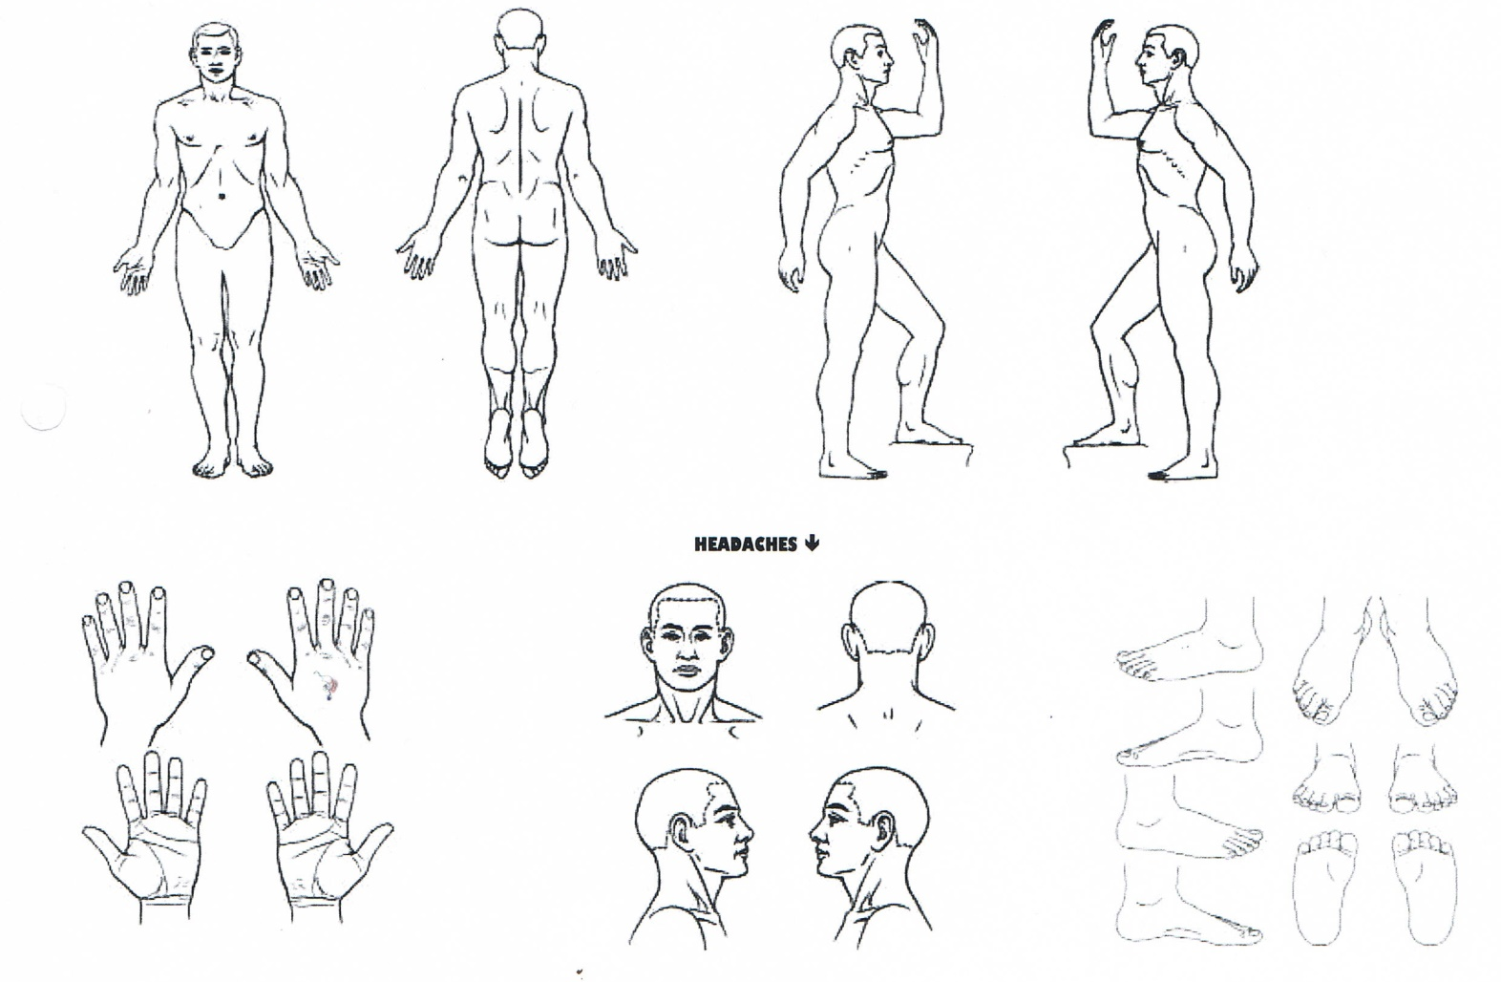

Do changes in the weather make your problem areas better or worse?

Does applying heat or cold make your problem area better or worse?

What do you to try to alleviate your symptoms and does it help?

