Acupuncture Intake

Please complete this questionnaire carefully. The information you provide will assist in creating a complete health profile for you. All of your answers are strictly confidential. If you have any questions, please ask.
Name (Last, First): |  | Gender: |  |  |  |  | DOB:  Age:
Relationship status: | Single Common Law Married Separated Divorced Widowed Other
Full Address: |  |  |  |  | Phone:  Cell:

Email Address:

Extended Medical Insurer: |  |  |  |  | Occupation:
Family/Referring Doctor: |  |  |  |  | Doctor’s Phone:
Emergency Contact:  Relationship to You: |  |  |  |  | Emergency Contact Phone:
How did you hear about us?

Have you had Acupuncture before?

PERSONAL HEALTH HISTORY
Medical History: |  |  | Asthma | High / Low Blood  Pressure |  | Kidney Disease
 |  |  | Arthritis | Pacemaker |  | Liver / Gall Bladder Disease
 |  |  | Broken Bones | Heart Disease |  | Seizures
 |  |  | Cancer | Bleeding Disorder |  | Stroke
 |  |  | Colitis / IBS / Crohn’s | Hepatitis ____ |  | Substance Abuse
 |  |  | Diabetes | Herpes / Shingles |  | Thyroid Imbalance
 |  |  | Gastritis | High Cholesterol |  | Trauma / Abuse Survivor
 |  |  | Gout | HIV / AIDS |  | Tuberculosis

CHIEF COMPLAINTS
Please indicate your chief concerns for your health:

- ____________________________________________________________________________________________________

- ____________________________________________________________________________________________________

Have you been given a specific diagnosis by a health professional for any of the above concerns?

MENTAL HEALTH
Is stress a major problem for you? |  | Yes |  | No
Please rate your stress level on a scale of 0 to 10 (0 = no stress; 10 = extreme stress) __________________
Do you feel depressed or anxious? |  | Yes |  | No
Do you suffer panic attacks or heart palpitations when stressed? |  | Yes |  | No

sleep
How many hours of sleep do you get a night on average? ______________________
Do you have trouble falling asleep? |  | Yes |  | No
Do you have trouble staying asleep? |  | Yes |  | No
Do you feel tired during the day? |  | Yes |  | No
Do you suffer from nightmares or frequent dreaming while asleep? |  | Yes |  | No
Areas of concern
Please mark the painful areas on the diagrams below and rate the discomfort on a scale of 0 to 10.
Do changes in the weather make your problem area better or worse?

Does applying heat or cold make your problem area better or worse?

Is there anything else that helps alleviate your symptoms?

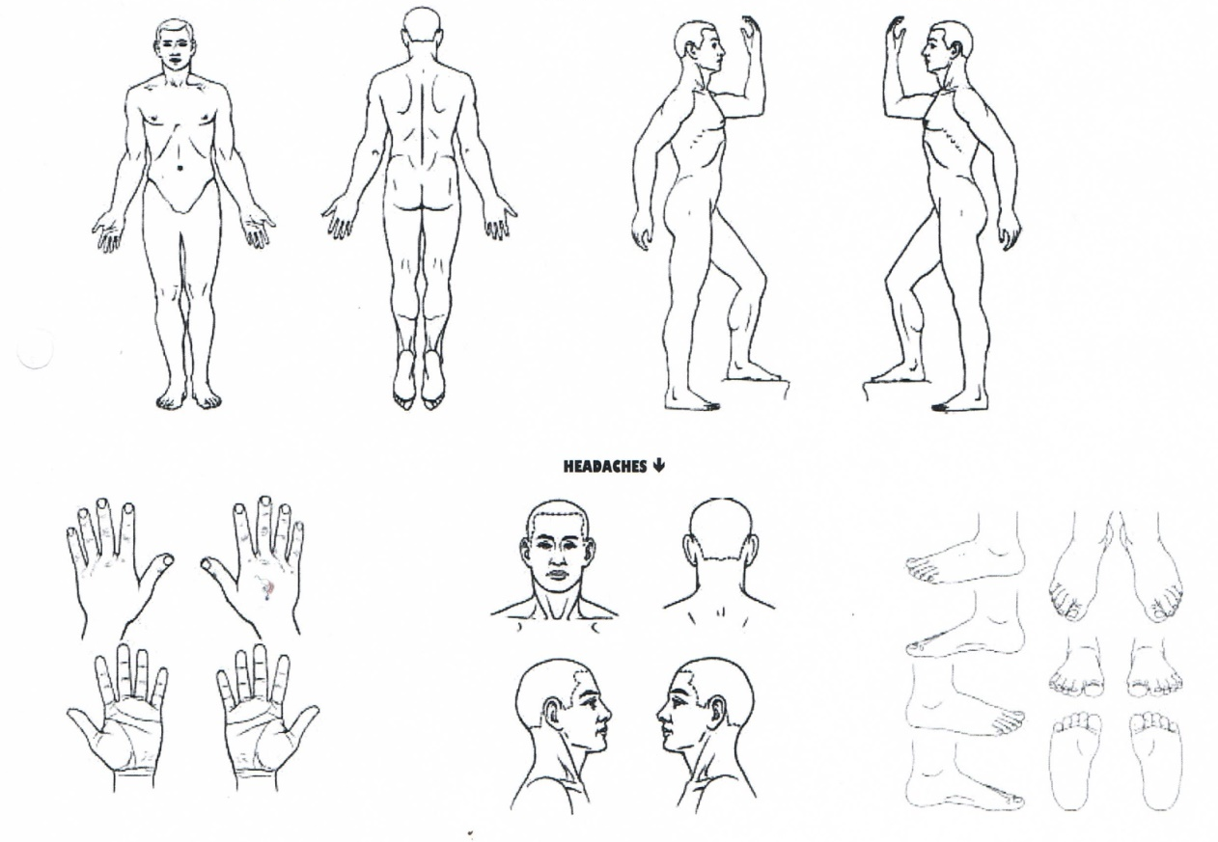
Other Comments/Concerns:

